Title
Thirty-six years in the White House, by Thomas F. Pendel, door-keeper; Lincoln-Roosevelt.
Creator
Pendel, Thomas F. b. 1824. (Thomas Franses)
Created / Published
Washington, The Neale Publishing Company, 1902.
Robert Todd Lincoln was 21 years old and Tad Lincoln was 11 years old at the time of their father’s death.
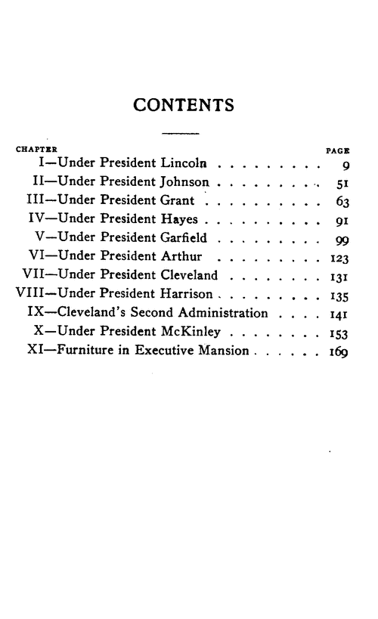
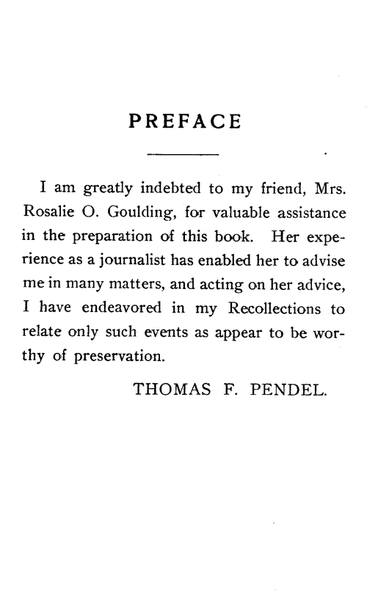
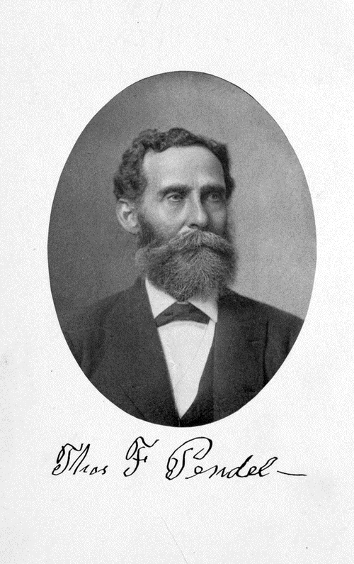

Page 41 – 45
Probably about twenty minutes before eleven o'clock, I stepped up to the door in answer to another ring at the bell. Who should be there but Isaac Newton, the Commissioner of Agriculture. This is now a Cabinet position, but was then a commissionership. I admitted him inside the door, and at once closed it. He was a bosom friend of President Lincoln. I was thoroughly acquainted with him, and I knew to whom I was talking. He said to me, "They have shot the President. And the bullet," he said, "has entered the left side of his head." I immediately hurried upstairs, leaving him on the inside, and went to Captain Robert Lincoln's room. He had just come from the front that morning, where he had been doing duty on the staff of General Grant.
That room was directly over the front portico. When I got into his private room, he did not seem to be feeling very well, and had a vial in one hand containing medicine and a teaspoon in the other, as if he was about to take a dose of medicine.
As I stepped up to his side the teaspoon and the vial seemed to go involuntarily down on the table, and he did not take the medicine. I wanted to approach him gently and break the news to him about his father. So I simply said, "Captain, there has something happened to the President; you had better go down to the theatre and see what it is."
He said to me, "Go and call Major Hay," who was in the room now used by Secretary Cortelyou. That was Mr. Nicolay's and Major Hay's bedchamber at that time. I said to him, "Major, Captain Lincoln wants to see you at once. The President has been shot." He was a handsome young man with a bloom on his cheeks just like that of a beautiful young lady. When I told him the news, he turned deathly pale, the color entirely leaving his cheeks. He said to me, "Don't allow anybody to enter the house." I said, "Very good, Major. Nobody shall come in." They took their departure immediately for the theatre. They had been gone probably half an hour, when poor little Tad returned from the National Theatre and entered through the east door of the basement of the White House. He came up the stairway and ran to me, while I was in the main vestibule, standing at the window, and before he got to me he burst out crying, "O Tom Pen! Tom Pen! they have killed papa dead. They've killed papa dead!" and burst out crying again.
I put my arm around him and drew him up to me, and tried to pacify him as best I could. I tried to divert his attention to other things, but every now and then he would burst out crying again, and repeat over and over, "Oh, they've killed papa dead! They've killed papa dead!"
At nearly twelve o'clock that night I got Tad somewhat pacified, and took him into the President's room, which is in the southwest portion of the building. I turned down the cover of his little bed, and he undressed and got in. I covered him up and laid down beside him, put my arm around him, and talked to him until he fell into a sound sleep.
Ah! that was a sad night for the nation, and to me it was simply awful, for I loved Mr. Lincoln probably better than I loved any one else in all the world.
While I was putting little Tad to bed other men had taken my place at the door, but after he went to sleep I returned to my duty.

bosom-
acquainted-
portico-
vial-
pacify-
divert-

